REGISTRATION STEPS:
Step One. Registration is available at https://48carats.caiu.org/48caratsDN2/LogIn.aspx
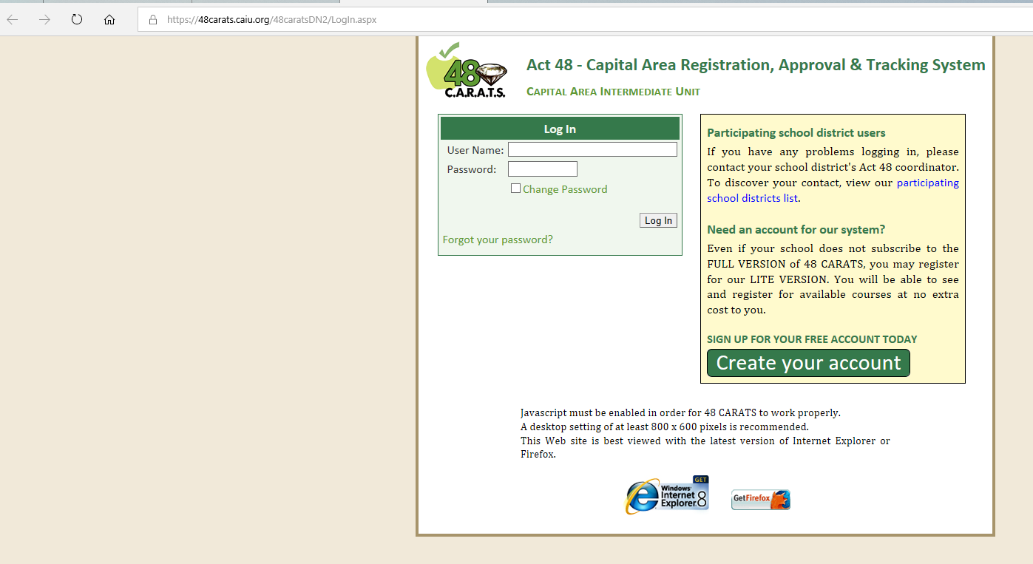

Step Two: If you already have an account, fill in user name and password. If you do NOT have an account, select the “Create Your Account” green button on the right side (circled for you in red on the image above). This will take you to the next page, where you must again select the green “Create Your Account”
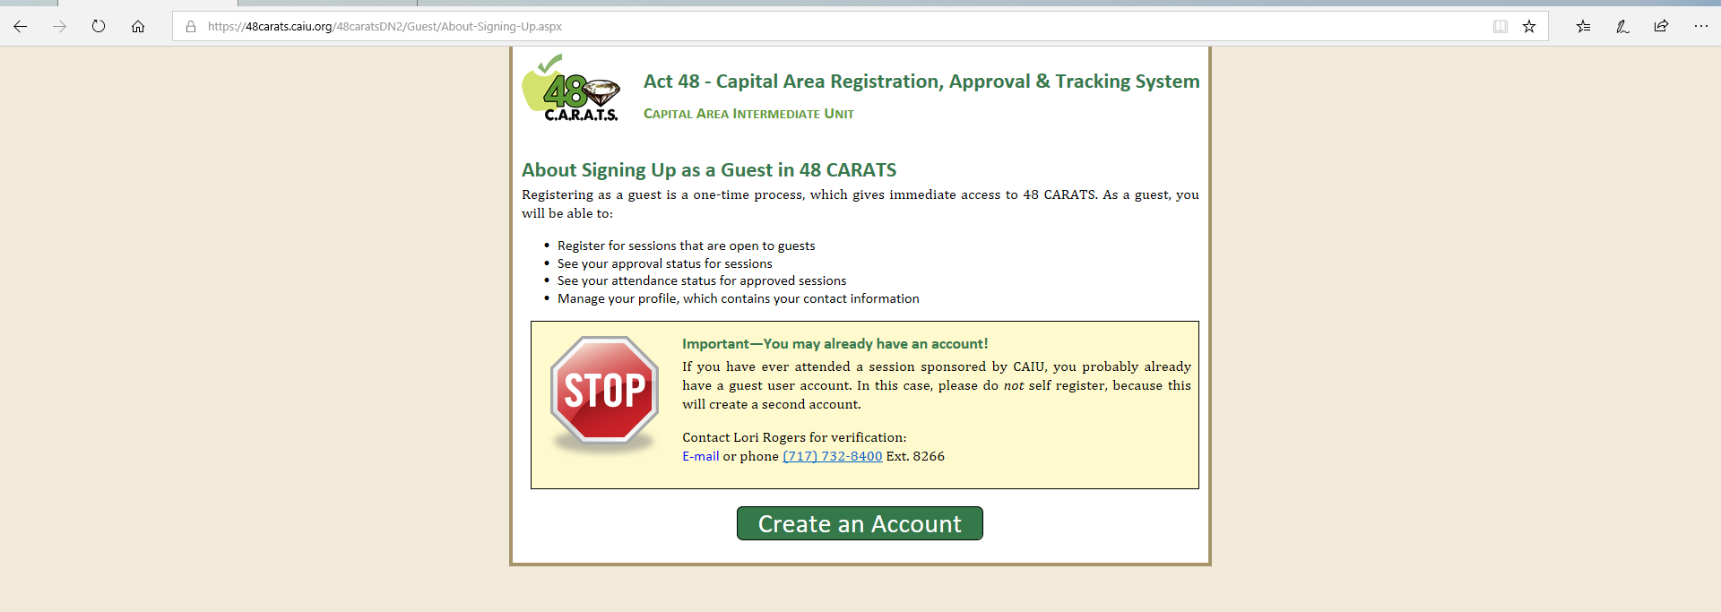

Step Three: Fill-In the following information

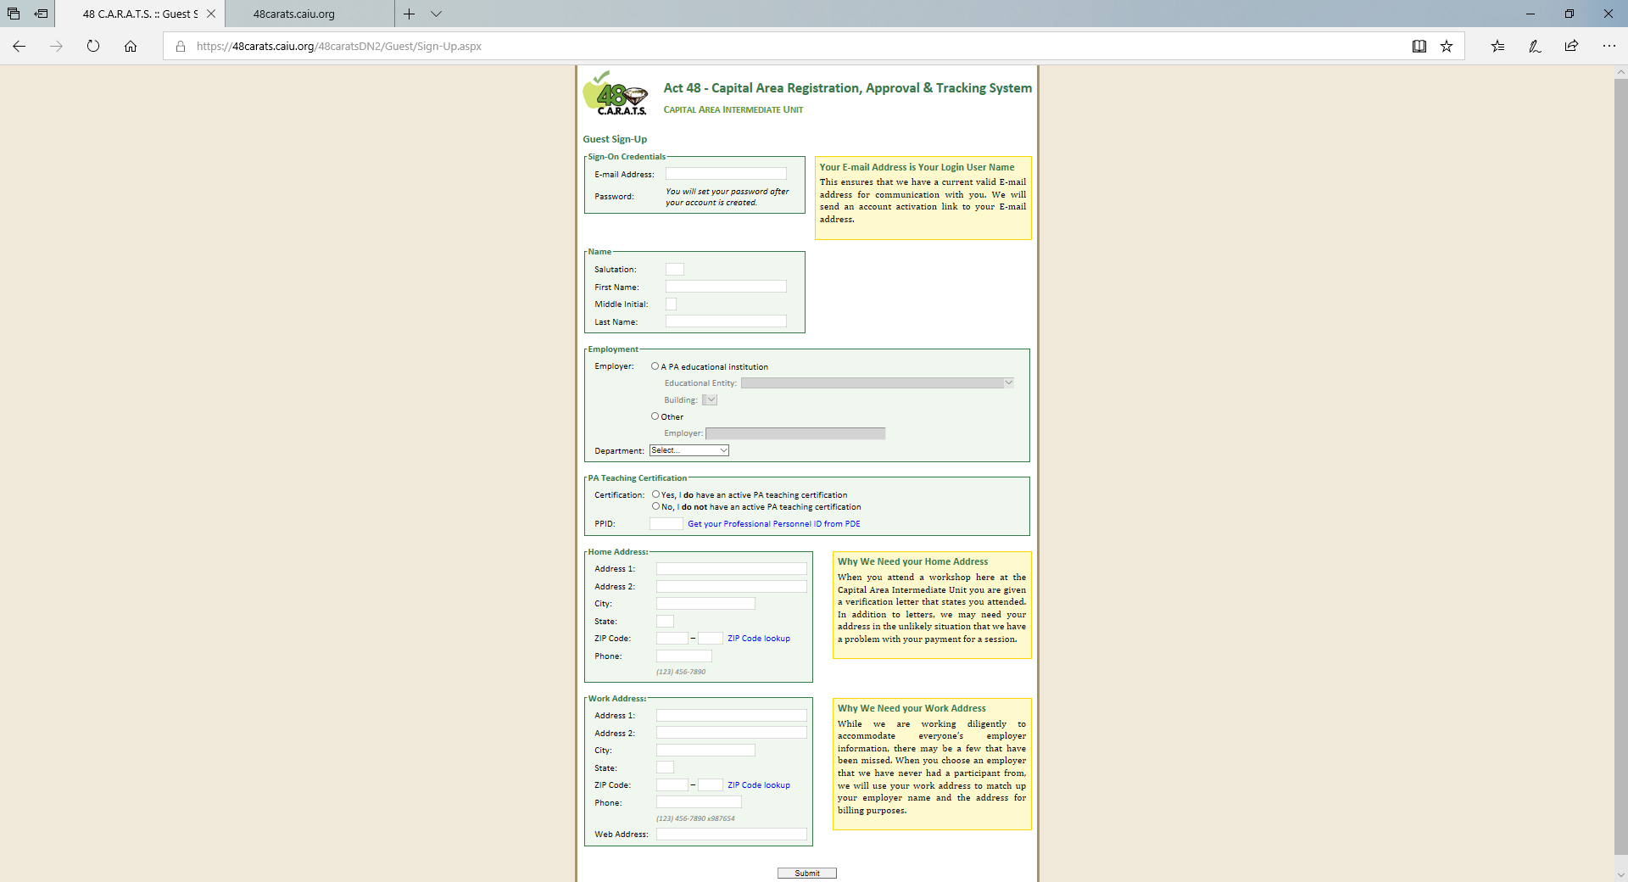

NOTE: Make sure you fill out the “Employment” section and “Work Address” section as depicted below.

Step Four: After selecting the “submit” button, the following screen will appear. Log into the email you signed up with for more instructions.

Step Five: The following email is an example of what you will receive after signing up (your hyperlink will differ from the one shown below).
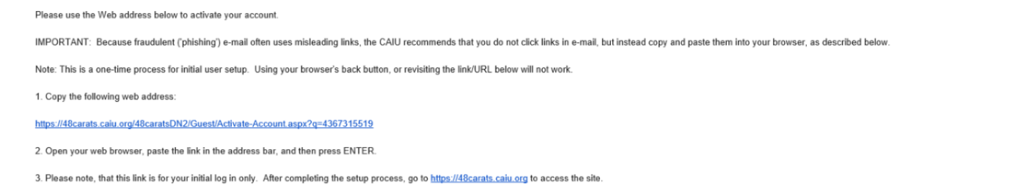

Step six: After selecting the first link, it will take you to this webpage screen where you must create a password.
NOTE: your username is the email address you used to sign up with.
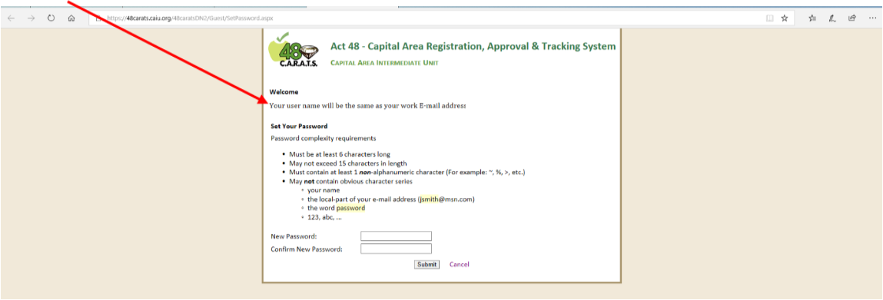

Step Seven. After creating a password, you will be directed to the following page where you should select “proceed to log in” which will direct you back to the original “Log In” page. Log in using your username (email) and pasword.
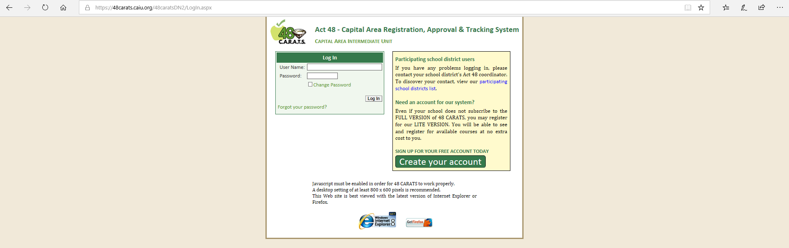

Step Eight: After logging in, you will see the following page where you can search for your selected program. Search for “High Impact Strategies for Student Teachers.” All sessions are not listed together. For additional dates, scroll through the program listings.
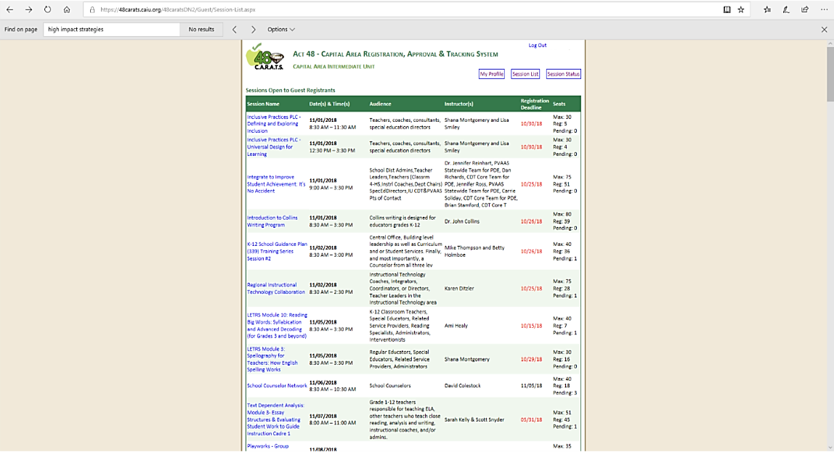

Step Nine: Select “Please bill my school district” and enter “Shippensburg University” in the comment box. IU15 will NOT collect anything from you but will invoice Shippensburg University and SU will pay for this training. Select “Register for this session”

Step Ten: Your screen will appear as follows. It could take between 1-2 weeks for your session to be approved. 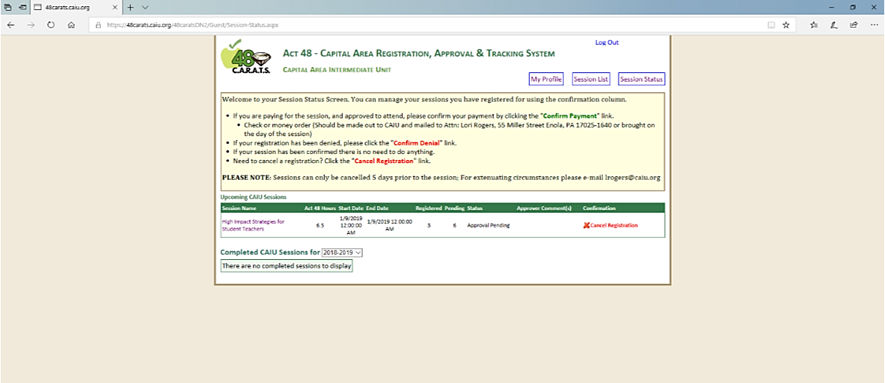
Step Eleven: You may log out at this time.

Note: When your registration has been approved, you will be sent a link to register for Mandated Reporter Training.

If you have any questions about the session or the requirements, you can contact Colleen Bushman at cbushman@caiu.org or (717) 732-8400 ext. 8634

