MBA 550: The European Business Environment

Course Overview

This is a 3 credit MBA elective course that will include an online component and a travel component. The course will explore business opportunities and challenges in the European Union. We will visit EU institutions in Brussels as well as meet with business and academic professionals in France and Italy. We will also visit sites of cultural interest. There will be some preliminary readings assigned, some online discussions in preparation for the trip, and a term paper due after the conclusion of the trip.

Anticipated Travel Itinerary

Thursday, May 16: Depart for the airport. This is very flexible and will be tailored to where each participant lives for easy access to a convenient airport. Fly to Paris.

Friday, May 17: Arrive in Paris. Eiffel tower and museums.

Saturday, May 18: Paris bike tour. Meeting with expatriate entrepreneurs. Free afternoon and evening in Paris.

Sunday, May 19: Free day in Paris

Monday, May 20: Train to Brussels. Visit EU institutions in Brussels, including EU Parliament. Dinner in authentic Belgian restaurant and tour of the Grand’Place.

Tuesday, May 21: Chocolate factory tour. Free afternoon and evening in Brussels.

Wednesday, May 22: Fly to Italy. Macerata University tour.

Meet with Macerate University faculty and students, free afternoon in Macerata.

Thursday, May 23: Italian winery tour, espresso machine manufacturer tour.

Friday, May 24: Italian shoe factory tour.

Saturday, May 25: Free day in Macerata

Sunday, May 26: Fly to Paris. Free afternoon and evening.

Monday, May 27: Return to Harrisburg/Shippensburg.

We will be staying in 3-star or better hotels with double occupancy. If you would like a private room, there will be an additional $600 fee. **Some breakfasts and at least two dinners will be included. Several lunches and other dinners** will be organized as plans get finalized. For all other meals, participants will be responsible for paying separately, although additional meals as a group are very likely depending on the final budget.

Course Budget and Costs (per person)

Round trip airfare to Europe $800

Lodging $600

European Transportation $500

Some Meals and Misc. expenses $400

**Total Travel Expense $2300**

In-State Tuition & Fees $1878

**Total Expense $4178**

If expenses turn out to be less than expected, extra money will be allocated for meals and/or other extra activities during the trip. If expenses turn out to be higher than anticipated, some additional payment may be necessary (but this has never happened in 15 years of organizing the trip).

Payment Schedule and Details

You will be required to make four separate payments. These payments are **non-refundable** once they have been made.

February 15: $1000

March 1: $700

April 1: $600

Planned Destinations

**Brussels, Belgium**

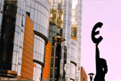As the headquarters to the EU (European Union) and NATO, Brussels is often referred to as The Capital of Europe. It is an international metropolis – a mosaic of languages, cultures, and traditions. Aside from the splendid and varied [architectural](http://www.visitbelgium.com/artandarchitecture.htm) styles of the city, Brussels also hosts over 80 [museums](http://www.visitbelgium.com/artculture.htm), numerous tourist [attractions](http://www.visitbelgium.com/bxlhighlights.htm), a vibrant [nightlife](http://www.visitbelgium.com/nightlife.htm), and more [restaurants](http://www.visitbelgium.com/food.htm) than you could count.

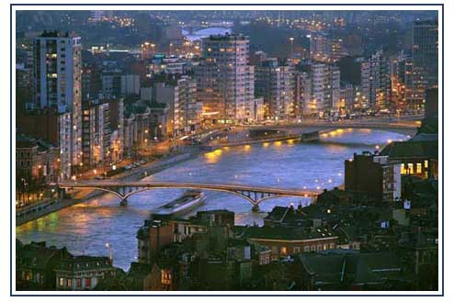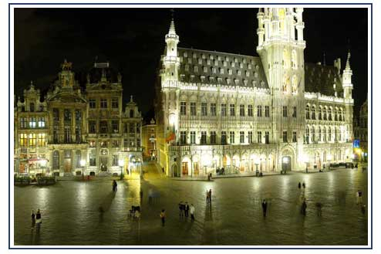

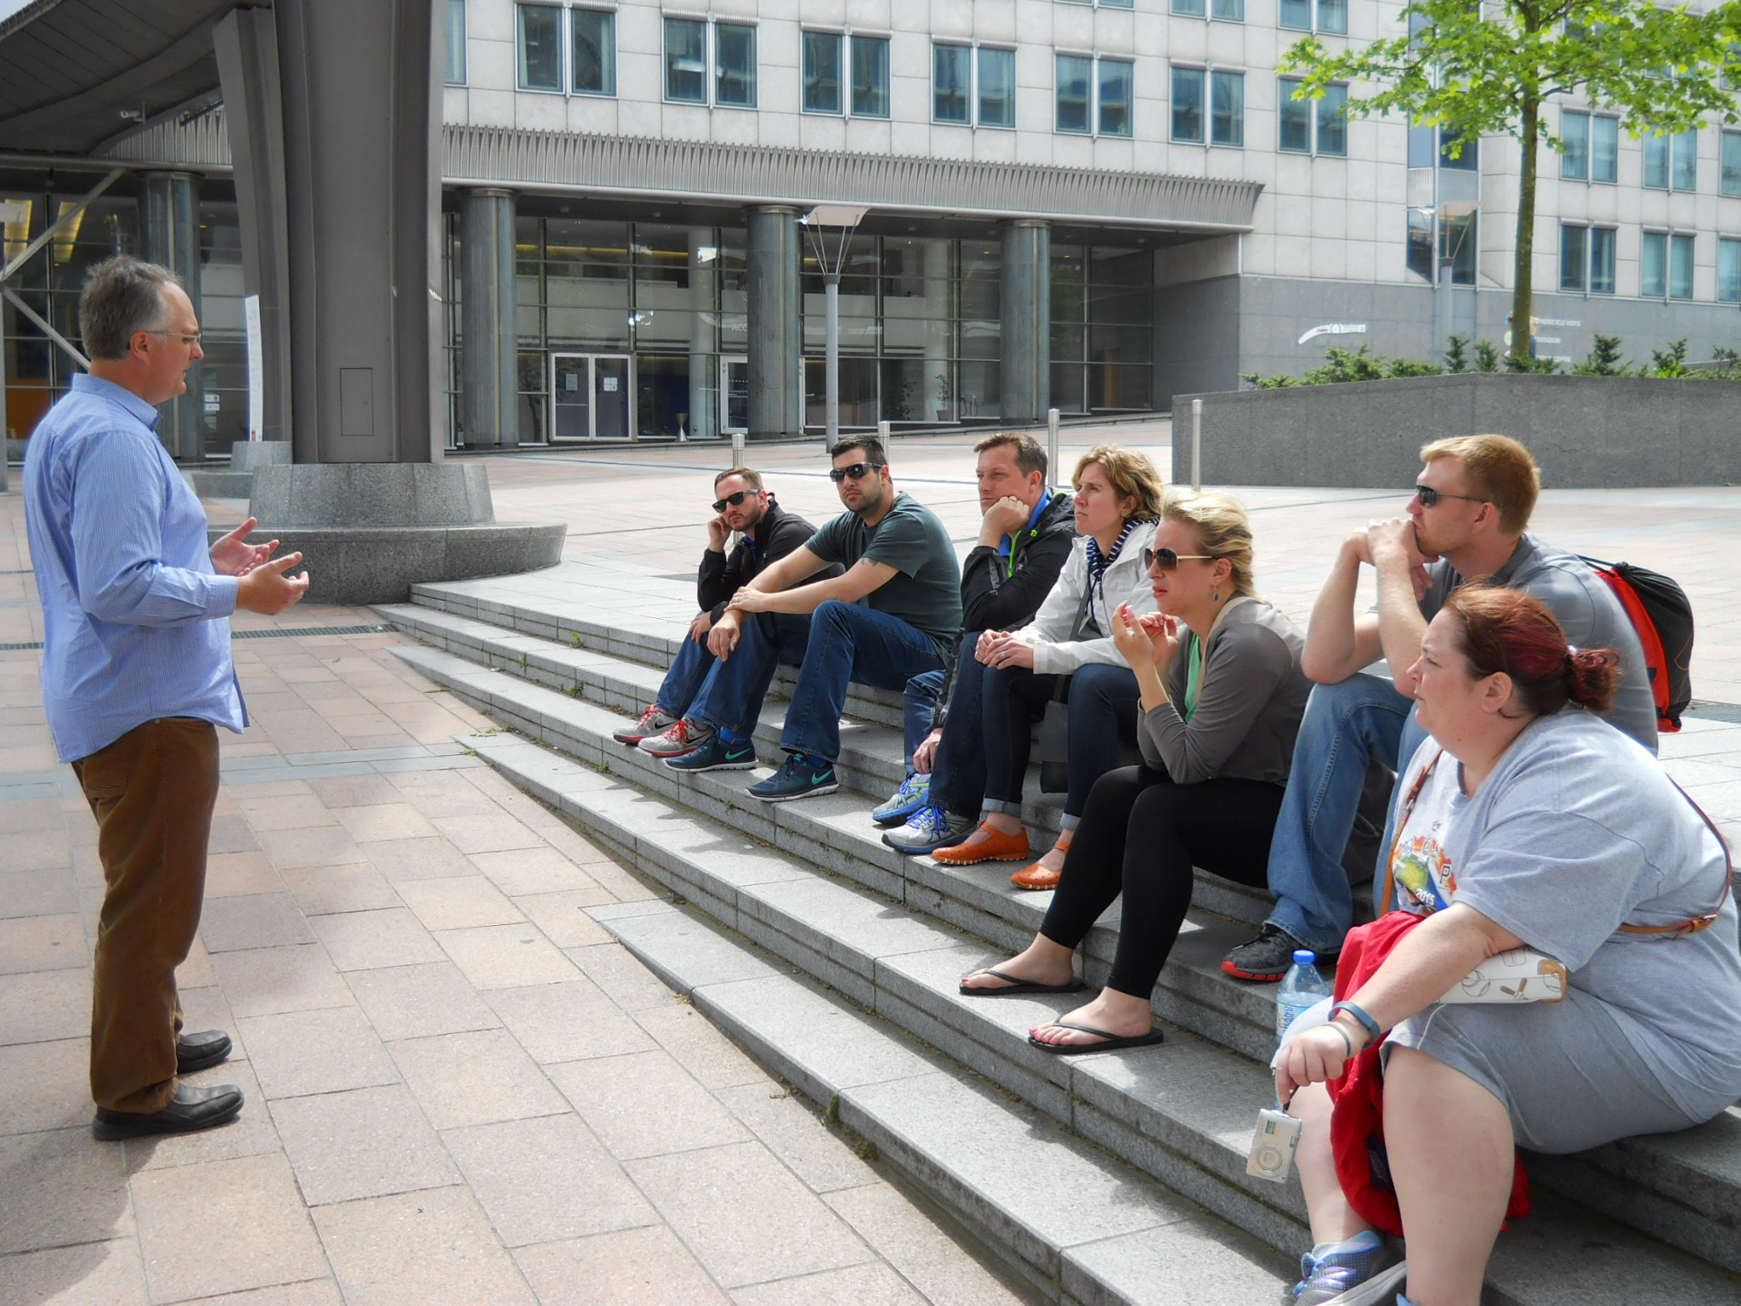

**Bottom of Form**

**Bottom of Form**

**Macerata, Italy**

Home to one of the oldest universities in Europe (Macerata University, founded in 1290), Macerata is also a thriving business hub with luxury shoe manufacturers, espresso machine makers, and high-end wineries in the region. Macerata is also a center for the arts and hosts one of the largest opera festivals in Europe in a gorgeous outdoor opera house.

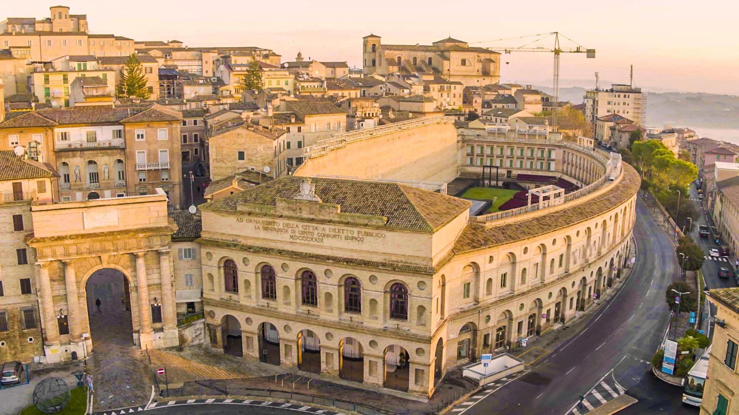

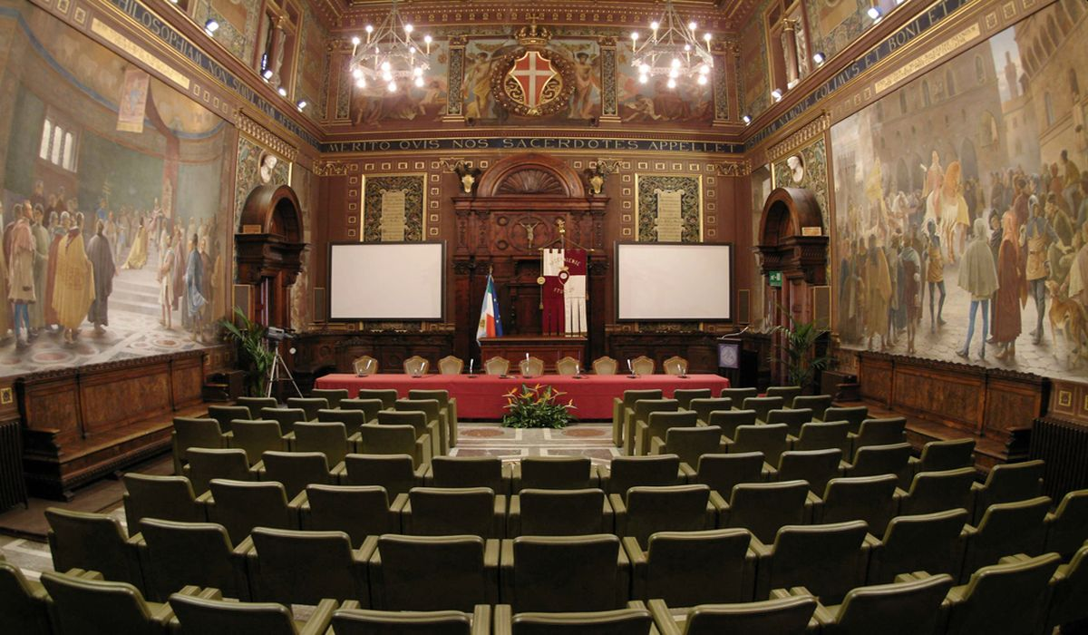

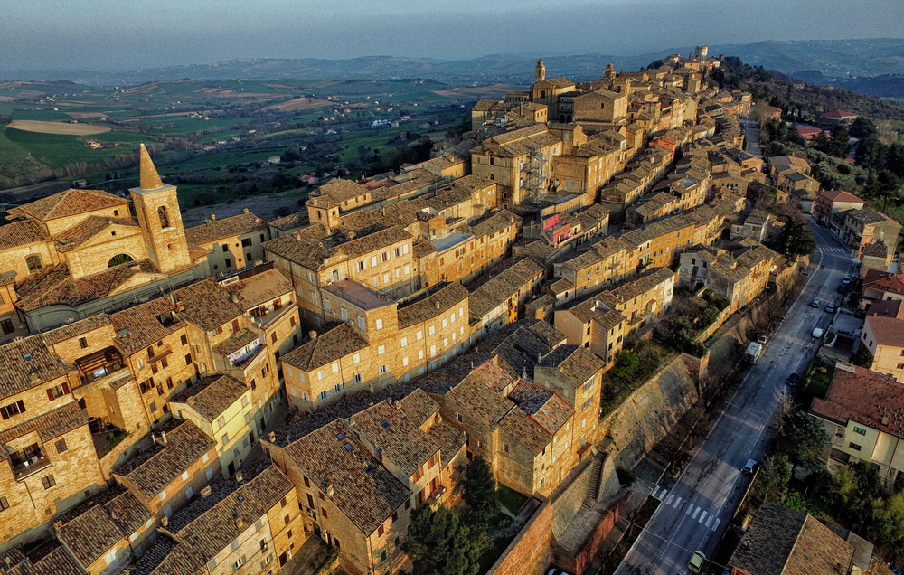

**Bottom of Form**

**Paris, France**

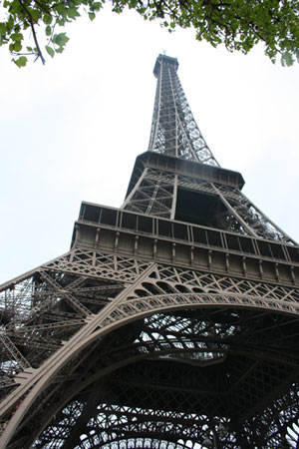

The “City of Lights”--Paris is the heart, and in many ways, the soul of continental Europe. Rich in history, culture, and architecture—you will never be lacking for something interesting to see or do during your visit. Walk down the Champs Elysees, admire the artistic treasures in the Louvre, or just sit in an outdoor café and take in the ambiance.

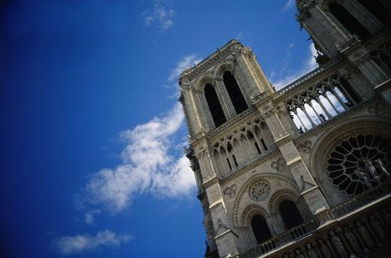

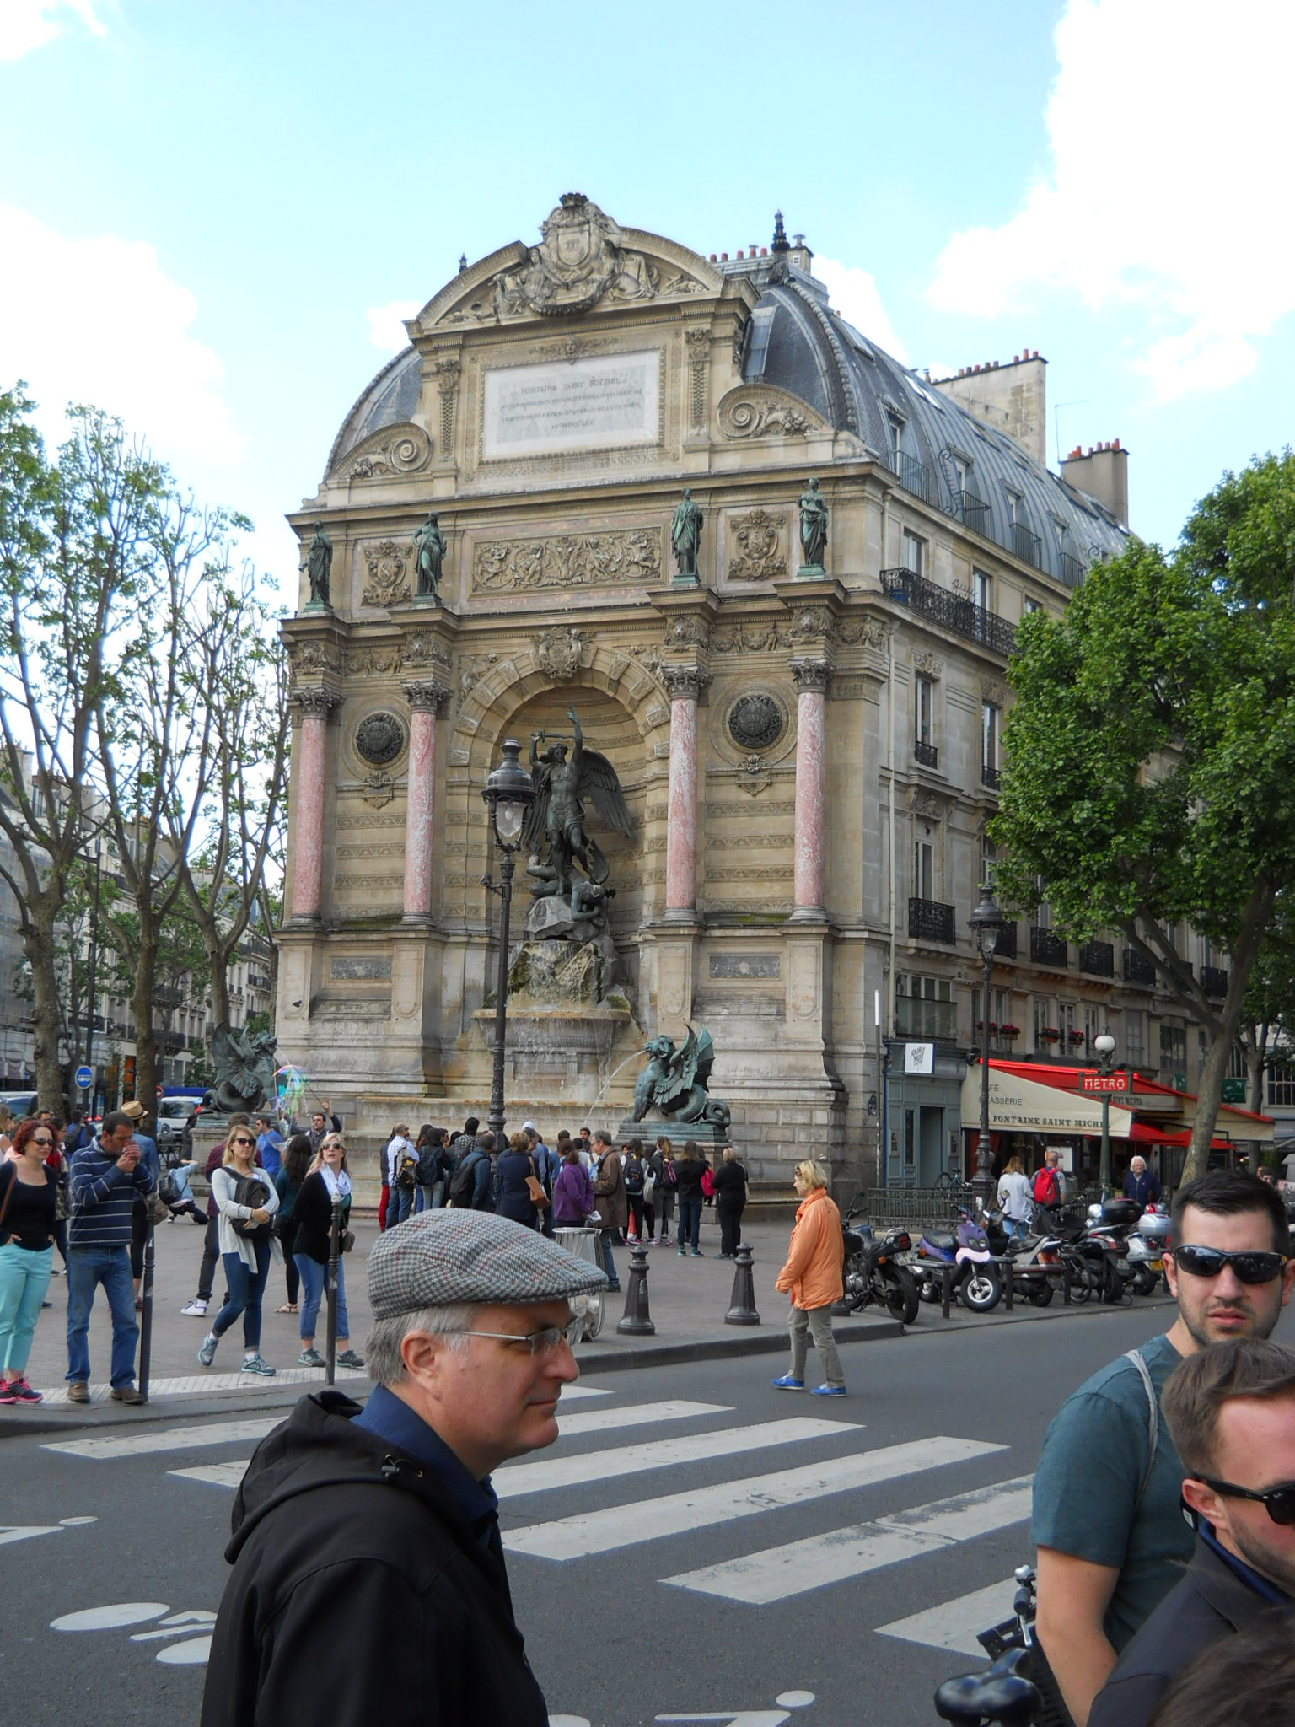 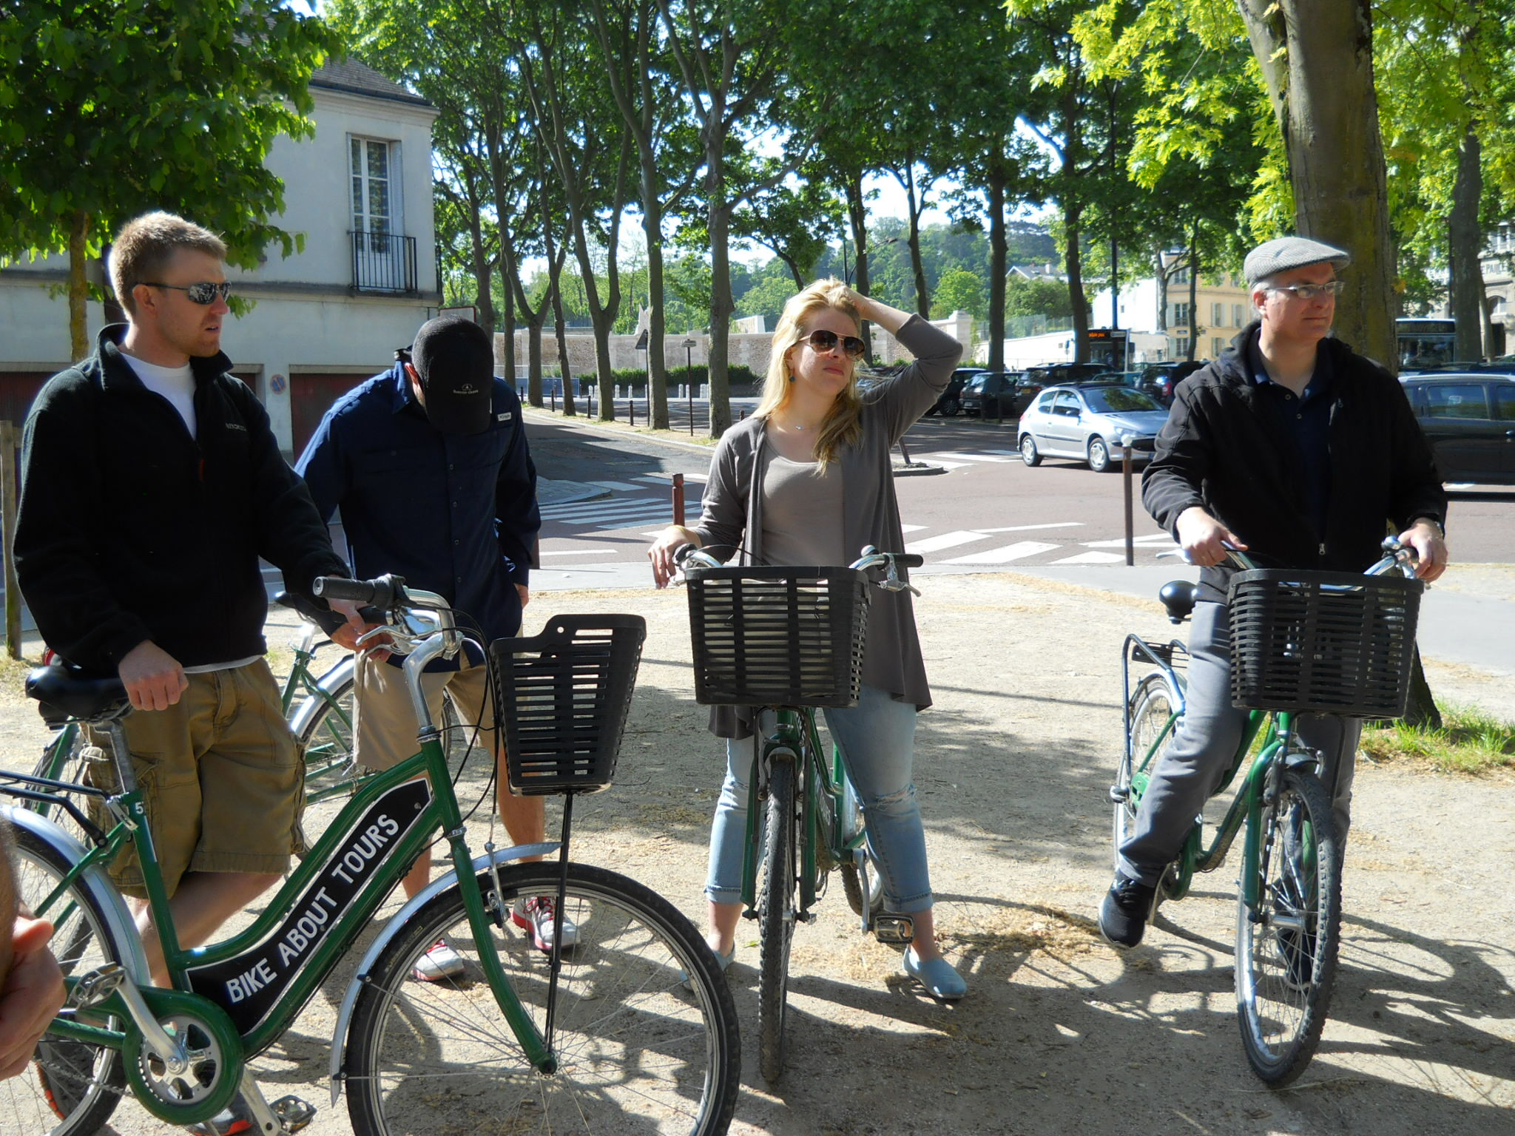

Enjoy a bike tour to the hidden parts of Paris, visit world-class art museums and enjoy the amazing French cuisine.