SPOC Document
A Strategic Planning Process (SPP) offered by the Strategic Planning Oversight Committee (SPOC)

Compounded by COVID 19, the world is in a state of flux. Our society is changing in ways both fundamental and profound. New realities are emerging for our country and for Shippensburg University. Confronted by the implications of the PASSHE restructuring, imminent decline in high school graduation populations, and dramatic shifts across everything from the political and social environment to technology’s role in the post- pandemic classroom, the answer to the question “Does my institution need to evolve?” seems patently obvious. Radical change is upon us, and either we attempt to exert control over it or we have it imposed on us entirely by outside forces and grim economic realities.
How best to view this reshaping? The article “Reimagining Higher Education in the United States,” makes a compelling argument for unconventional thinking. It challenges the shibboleth that universities be well-rounded and concludes “there may be more benefit to creating thoughtful differentiation, building on the institution’s existing strengths, resources, and local context. The question to ask is: ‘What should my institution be known for?’ There are many ways to differentiate, including student mix and outcomes, faculty development, research capabilities, facilities, and community impact.”
How then does Ship stand out? On the most essential level, any university--as an embodiment of enlightenment and education--has but one goal: the betterment of society. Faculty members make direct contributions to their disciplines and prepare students to make contributions by imparting knowledge and wisdom, encouraging intellectual curiosity, and cultivating certain academic attitudes and habits of mind. Indeed, seen in this light, every graduate is improving their community in some way, just as every piece of scholarship from every faculty member advances their field of expertise.
Contribution: the act of giving
toward the common good.
Given the unique blend of talented individuals and existing endeavors at Ship, we are well-situated to highlight and benefit from the wealth of contributions we make to the world.
When considering the four core values of Quality, Student Success, Telling Our Story, and Community Contribution, the last has often been perceived as a byproduct, an afterthought. But contributions to community must now become our driving force.
Our work must begin with a broad conceptualization of community, almost boundless in the digital era, as well as a foregrounding of some concepts not always associated with academia—kindness, generosity, empathy, gratitude, genuine inclusion. Fortunately, these are virtues engrained in the culture at Shippensburg University, espoused by our faculty and embraced by our students. First and foremost an academic institution, we are unique in that the type of scholarship and service at which we excel is oriented to practical outcomes, the improvement of the lives of real people. It is so much part of our values that it permeates and arises from the fundamental academic work we do.
This new vision can’t be considered a mere matter of repackaging—rebranding us as institution that cares about the local community and “gives back.” Certainly, part of this endeavor will include spotlighting important ongoing acts of volunteerism, such as the recent effort to plant trees in the area, free summer programs for students, the many campaigns to serve the underprivileged.
But as importantly, it means fully valuing faculty research and what happens in all our classrooms. Our Political Science courses facilitate citizenship; our Teacher Education faculty's work has a multigenerational, cascading impact. Faculty members from disciplines as varied as Social Work and English engage students in grant writing that directly serves the community; the research of undergraduates and professors in History helps to preserve the past while the efforts of those in Biology, Geo/Environmental Studies and Sustainability Studies work to protect our futures. Students in the College of Business not only learn the principles of accounting, but they also apply those when providing free tax assistance to low income community members. Too numerous to list here, examples could be drawn from every discipline. In addition to all these, we must envision new initiatives, tapping the vast talent in our midst.
The opportunities for networking and recruiting will be abundantly clear as we engage with the community, businesses, and schools in ever-expanding ways. Helping others will benefit us. During this strategic planning period, as we emerge into the next normal, our university will become renowned not just as an academy of higher learning but a thriving engine of positive contributions. Illuminating our identity as a caring agent of change and improvement will speak to a generation that of course wants cutting edge job skills and career path options, available at every college. At Ship, they will seek what they yearn for—their truest purpose.

Goal
Building on the achievements of past (as well as ongoing) planning efforts and viewing them through the lens of our dynamic present, the university’s 2021-2024 Strategic Plan will plot a clear and compelling course for our school’s best future. The goal is to produce a concise document that articulates our institution’s values, vision, and mission and offers an array of commensurate recommendations. Attention will be paid throughout the process to the incipient lessons of 2020.

Process (Structural Formation)
Shippensburg University’s Strategic Planning Process will entail two tiers. This section illustrates the structural formation of the full process as well as Tier I at the operational and tactical level.

Tier I Charge/Process (Timeline: August 2021)
The 2018 Visioning Plan identified four key values, which will serve as the basis for the creation of four insight teams. Each will draw from trustees, administrators, faculty, students, and staff. Two Co-Chairs of each Insight Team will join SPOC Co-Chairs Neil Connelly (Professor of English) and Sue Mukherjee (Chief Strategy Office and Senior Associate Provost) to form the original ten-member Strategic Planning Oversight Committee. Connelly and Mukherjee will each monitor the progress of two insight teams.
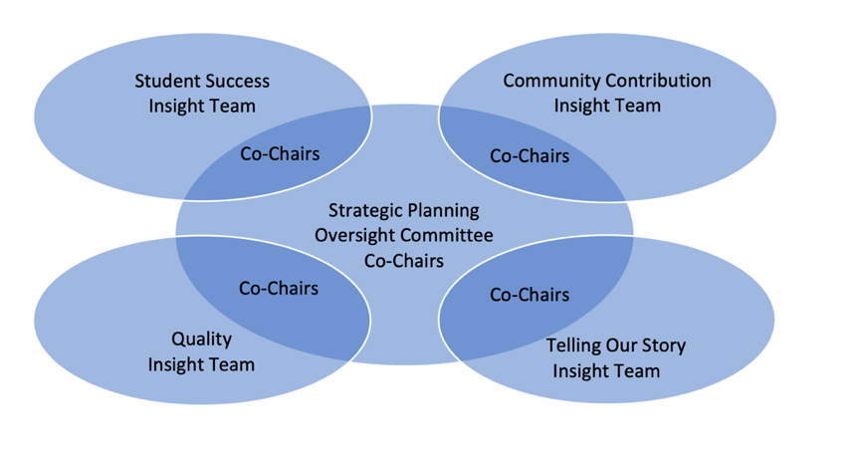
An Academic Dean, a Subject Matter Expert, and the Chief Equity, Inclusion, and Compliance Officer and Title IX Coordinator were added to the Oversight Committee to provide important viewpoints.

Process (Team Assignment)
Each Insight Team will review relevant sections of the Visioning Team Report and the Strategic Plan 2016-2021 vis a vis our current reality—the landscape of education post-pandemic, post-George Floyd. For additional context, teams may consider Middle States SIR, the university COVID site and other key planning documents. Then, viewed from the perspective of our new vision and mission, through whatever means they find most efficient (SWOT, Opportunities & Obstacles) each insight team will create:
- A succinct profile of the current status of their assigned priority.
- A focused list of insights/recommendations regarding their assigned priority—what ongoing initiatives need continued support, what’s not working, what new directions might we explore? Ideally these will be offered in a hierarchy.
- A few general suggestions for ways to promote the school’s identity as a contributor to society.
The Insight Teams’ reports will serve as the essential text of the new Strategic Plan.

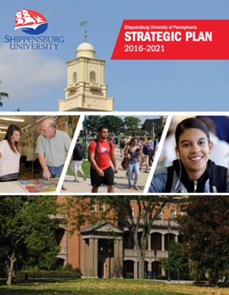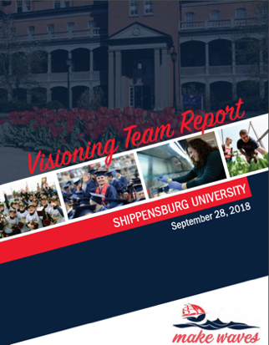

Student Success
Quality
(campus atmosphere, institutional health)
Telling Our Story
Community
Contributions

Profile &
Recommendations
Profile & Recommendations
Profile & Recommendations
Profile & Recommendations

Proposed Vision (Where do we want to end up; future oriented)
To make the world a better place, one student at a time. To create and sustain a nurturing, truly inclusive institution which brings together student scholars and active faculty in dynamic educational venues, ultimately culminating in improved, richer lives for our graduates and their communities.

Proposed Mission (How do we get to Vision from today; present tense)
To prepare students to be meaningful contributors. To scrutinize the shifting educational landscape and our profile within it to collectively devise fiscally-responsible, prudent approaches to: provide guidance and enrichment to student learners pursuing their own success and purpose; foster significant contributions to creative endeavors and academic disciplines; embrace our role as an impactful regional leader; and share the Ship story of the myriad ways these pursuits benefit society.

Aligning Four Key Priorities with Mission & Vision for Insight Teams
Quality Student Success Community Tell Our Story

Proposed Vision (Where do we want to end up? Future-oriented)
To make the world a better place, one student at a time. To create and sustain a nurturing, truly inclusive institution which brings together student scholars and active faculty in dynamic educational venues, ultimately culminating in improved, richer lives for our graduates and their communities.

Proposed Mission (How do we get to vision from today? Present timeframe)
To prepare students to be meaningful contributors. To scrutinize the shifting educational landscape and our profile within it to collectively devise fiscally responsible, prudent approaches to: provide guidance and enrichment to student learners pursuing their own purpose and success; foster significant contributions to creative endeavors and academic disciplines; embrace our role as an impactful regional leader; and share the Ship story of the myriad ways these endeavors benefit society.

Current Values: (How we'll operate/behave)
Student Centered; Learning; Engagement; Access and Equity; Community; Innovation

Proposed Values (to be distilled from recommendations).

DEI Statement. The Vision Statement’s goal “To create and sustain a nurturing, truly inclusive institution” should be seen as a signal of Shippensburg University’s paramount commitment to an environment where all people benefit from a feeling of belonging and being valued. To further solidify this outcome, the Diversity, Equity, and Inclusion Strategic Plan 2021-2024 will be developed.

Insight Team Formation
Principles of Team Composition: To encourage robust collaboration and the inclusion of a wide range of diverse perspectives, Insight Teams were formed from distinct stakeholder cohorts. Even within cohorts (such as faculty), attention was paid so as to include membership from different academic disciplines, experience levels, and backgrounds.

One member from the Council of Trustees
At least one faculty member from College of Business.
At least one faculty member from College of Education and Human Services.
At least one faculty member from faculty not in a college.
At least two faculty members from Arts and Science.
At least one student.
At least 2 staff.
At least one administrator and one coach.
Each Insight Team should also include one member of the 2018 Visioning Team. Across the four teams, there should be a representative of the lab school and a department secretary.

Given the importance of the project and its long-term goals, adding a trustee to each team was deemed essential. Trustees are in the unique position of possessing a strong understanding of Ship but also of the larger world in which they play significant roles. At this stage in the planning process, their thoughts and ideas should join with others to be certain that the important insights are collected. Engaging them in this way will also ensure their engagement and support leads to more than Trustee approval of the strategic plan but real confidence in the planning process.

To provide additional layers of feedback, a draft of the Insight Teams’ reports will be shared with governance groups and representatives of key shared governance bodies and groups that produced critical reports and university, PLA, and the campus community. A subsequent draft will be shared with an Expert Advisory Group composed of alumni and representatives of the Foundation and local community.

Faculty Staff Student Admin. Trustee Visioning Team Member

Telling Our Story: Co-Chairs [BNS] Mohammad Rahman & Lorie Davis
Chuck Black
Chase Slenker
[E&HS] Sam Benbow (Social Work)
[A&S] Matt Ramsey (HCS)
[A&S] Toru Sato (Psychology)
[A&S] Claire Jantz (Geo, ESS)
[E&HS] Joohee Sanders (Exercise Science)
[UN] Eyoel Delessa (Library/Adjunct Perspective)
Alex Karlheim (LLC)
Maya Mapp (Director of Admissions)
Lori Smith
Kurt Dunkel (Coordinator of Connection AOD Program, Commuter Support Program Assistant Track Coach)
Alexa Matia (PCDE)
Jamie Rhine (Director of Technology Support)
Ken Bach
Leanne Piscotty (Coach)

Community Contributions: Co-Chairs [A&S] Marc Renault (Mathematics) & Kim Garris
Matt Steck
Luke Hershey
[E&HS] Cheryl Slattery (Teacher Education)
[A&S] Allen Dietrich-Ward (History)
[BNS] Viet Dao (Accounting)
[BNS] Wendy Becker (Marketing)
[A&S] Trever R. Famulare (Red Raider Band, Music Prof)
[A&S] Carol Wellington (Engineering)
[UN] Kirk Moll (Library)
Alexandra Jones (Community Youth Mobilizer/Social Work Department)
Javita Thompson, Director, First Year Experience and Community Engagement
Victoria Kerr, Career Center
Mark Chimel (Director of PCDE)
Ashley Grimm (Assoc AD)
Holly Garner, Lab School Director
Tara Zollinger (Coach)

Student Success: Co-Chairs) Ashley Lewis & Wendy Kubasko [EHS]
Brian Lowe
Justin Sentz (Chief Information Technology)
[A&S] Laurie Cella (Univ 101)
[UN] Chad Bennett (chair of the Department of Academic Services)
[UN] Linwood Vereen
[BNS] Michael Coolseen
[UN] Tomoko Grabosky (Counselling)
[A&S] Luis Melara (Mathematics, Assistant Director Honors College)
Kapri Brown (Multicultural Student Affairs)
Shaliyah Kinsley (Admissions Recruiter)
Rochelle Plummer
Bill Yost
Alix Rouby (Director of Internships, Career Mentoring)
Alison Van Syoc (Coach)
Lance Hines-Butt
Lucas Everidge
Skylar Walder

Quality: Co-Chairs [EHS] Lynn Baynum & Jose Ricardo
George McIlwee
[A&S] Emily Kramer (Biology)
[A&S] James Hamblin
[E&HS] Matt Fetzer (Criminal Justice)
[UN] Wes Mallicone
[A&S] Alice Armstrong (Engineering)
Eric Zeglen
Mindy Fawkes
Jennifer Milburn
Robin Dolbin
Trina Snyder
Lorelei Isbell
Dave Osanitch (coach)
Abdulomar Tucker (student)

Insight Team Co-Chair Executive Responsibilities
- Review Mission and Vision Statements and provide team comment
- Develop recommendations pertaining to your priority
- Assist in translating recommendations to strategic objectives and values
- Refine as draft strategic plan is disseminated
- Advocate and help with implementation

Role of Trustees
Trustees are in the unique position of possessing a strong understanding of Ship but also of the larger world in which they play significant roles. At the Insight Team stage in the planning process, their thoughts and ideas should join with others to be certain that the important insights are collected. Engaging them in this way will also ensure their engagement and support leads to more than Trustee approval of the strategic plan but real confidence in the planning process.

A video shared with the insight teams at the January 28 Kick Off can be viewed here: Unveiling Spoc Doc.

Additional Layers of Consultation and Feedback
Governance Groups
College Councils
Graduate Council
Teacher Ed Council
Gen Ed Council
Student Affairs Council
Student Government/Graduate Student Advisory Board

Expert Advisory Group
Composed of alumni, Foundation representatives, community members, and graduates of the President’s Leadership Academy and the Quality Matter pedagogical training program.

Timeline & Deliverables Tier 1
- January 28, 2021: Insight Team, Co-Chair, Chair meeting with President Carter

- February 15, 2021: Expert Advisory Group identified (invitations sent by February 20)

- March 25, 2021: Individual priority profiles and recommendations submitted by Insight Team Co-Chairs to SPOC

- April 15: Revised Insight Teams Report Due

- April 29: SPOC Executive Summary (with overview of process, draft vision, mission, and updated recommendations) shared with EMT, APSCUF President, and President, governance groups, PLA, campus community.

- June 7: Revised SPOC Executive Summary submitted to EMT, APSCUF President, and President. Following, it is submitted to the SPP Expert Advisory Group (Foundation, Alumni, Community).

- June - July, 2021: Feedback and Revisions (including conversion of Insight Team recommendations into Strategic Objectives and Values). Draft of Strategic Plan 2021-2024 (Tier 1) developed.

- August 2021: Presentation of Ship Strategic Plan (Vision, Mission, Strategic Objectives) to Council of Trustees
II. Tier 2
Tier II of Shippensburg University’s Strategic Planning Process will entail grounding the strategic objectives developed from Tier 1 with relevant metrics and aligning university plans to the established strategic plan. This includes but is not limited to: Program Planning and Budget & Facilities Master Plan, Academic Master Plan, Strategic Enrollment Management Plan, Technology & Library Plan, Athletics Master Plan, College of A&S College of Education, and the College of Business Strategic Plan.

As thoughtfully explored in “The New Normal: Higher Education in a post-COVID-19 World” https://www.tiaainstitute.org/publication/new-normal-higher-education-post-covid-19-world
https://www.mckinsey.com/industries/public-and-social-sector/our-insights/reimagining-higher-education-in-the-united-states
“Younger generations take the issue of social purpose as a personal calling, and the COVID-19 crisis appears to have bolstered this commitment. Nearly three-fourths of respondents say the pandemic has highlighted new issues and made them more sympathetic to the needs of others. About 70% of respondents say they have already taken actions to have a positive impact on their communities, and nearly three-quarters say they plan to do so once restrictions have been lifted.” https://deloitte.wsj.com/cmo/2020/07/17/pandemic-reveals-resiliency-of-gen-z-millennials/
These recommendations will translate into objectives and goals in the Strategic Plan upon acceptance by university community.
For more, consider this: https://www.forbes.com/sites/brandonbusteed/2019/04/10/whats-the-purpose-of-college/?sh=1950d04e354e
Program Planning and Budget & Facilities Master Plan, Academic Master Plan, Strategic Enrollment Management Plan, Technology & Library Services – Strategic Plan Athletics Master Plan, College of A&S College of Education, College of Business Strategic Plan, Middle States Report/SIR

