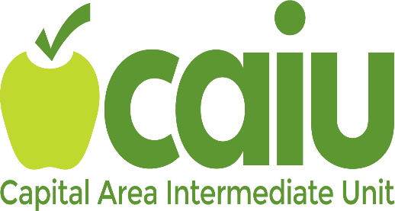

Virtual High Impact Strategies Training

What types of high impact strategies do effective educators use to engage all learners? Join us for a synchronous virtual professional development opportunity where you will explore current educational topics. Content includes Multi -Tiered Systems of Support (MTSS), Social Emotional Learning (SEL), active engagement, addressing learner variability, instructional and assistive technology, and educator effectiveness. This conference style day of professional learning features various forms of presentation modalities, breakout sessions, and collaboration/networking opportunities. Participants will leave with access to a slide deck of high impact engagement strategies that can be applied across contexts and with diverse learning populations.

Cost‐ $55.00
This course will be a one-day synchronous session.
To register please us the link below:
https://bit.ly/CAIUwebreg
(Instructions for registration will be provided separately
DATES:
Thursday, April 7, 2022

Wednesday, May 18, 2022

Tuesday, August 9, 2022

Wednesday, August 17, 2022

Wednesday, December 14, 2022

Wednesday, January 11, 2023

Wednesday, April 5, 2023

Wednesday, May 17, 2023

Wednesday, May 24, 2023

Questions? Call Mary Maronic (717) 732‐8400 ext. 8515 or email mmaronic@caiu.org

