Xfinity Stream TV app on Samsung Smart TVs
Comcast is collaborating with equipment manufacturers to bring the Xfinity Stream app to compatible Roku devices, Samsung Smart TVs and other Partner Devices. The Xfinity Stream app delivers live broadcast channels, linear cable channels, cloud recordings and video on demand, all without the need to rent an Xfinity TV Box from Comcast.
The Xfinity Stream app is currently offered in a "beta" version that does not include the full set of features and functionality included in the Xfinity Stream app for mobile devices and web portal. Future releases of the app will include additional features and functionality, as well as improved stability and optimization. When using the "beta" app, you will not be charged an "additional outlet" service charge. Pricing may change in the future.
Please note that we continue to believe Xfinity X1 is the best way to watch Xfinity TV, and not all features of X1 are available if you choose to use a Partner Device.

Activate the Xfinity Stream Beta App on Samsung Smart TVs

Getting Started
You will need to create a Samsung account and link it to your Samsung Smart TV before you download the Xfinity Stream Beta app. See detailed instructions on account creation and device linking.
The Xfinity Stream Beta app is available on the following Samsung device models:
- 2018 TVs with minimum software version T-KTM2AKUC 1131.9 and Model Codes NU8500, NU850, NU8000, NU800, Q9F, Q8F, Q7C, Q7F and Q6 [F = Flat, C= Curved]
- 2018 TVs with minimum software version T-KTM2LAKUC 1131.9 and Model Codes NU7300, NU730, NU7200, NU7100 and NU710
- 2018 TVs with minimum software version T-KTSUAKUC and Model Code UNXXNU7090
- 2018 TVs with minimum software version T-KTSNAKUC 1131.9 and Model Codes N5510, N5500, N5350, N5300, N4500, N4350 and N4310
- 2017 TVs with minimum software version T-KTMAKUC-1210.8 and Model Codes Q9F, Q8C, Q7F (Flat), Q7C (Curved), MU9000, MU8500, MU8000, MU7600, MU7500, MU750, MU7100, MU700, MU7000, MU6500, MU6490, MU6300, MU630 and MU6290
- 2017 TVs with minimum software version T-KTSAKUC-1210.8 and Model Codes M5300, M530, M4500 and M450
Follow these steps to determine your TV model and software version:
- Make sure your Samsung Smart TV is connected to the Internet.
- Press the Smart Hub button on your Smart Control remote to go to the Samsung Home screen.
- Scroll to and select the Settings icon (gear to the right).
- Arrow down to Support.
- Arrow right, then down, then select About this TV.
- From here, you will see the Model Code, Serial Number, Software Version, etc.
Next, follow these steps to add the Xfinity Stream Beta app to your compatible Samsung Smart TV:
- Make sure your Samsung Smart TV is connected to the Internet.
- Press the Smart Hub button on your Smart Control remote to go to the Samsung Home screen.
- Scroll to and select Apps.
- Select the Magnifying Glass icon.
- Enter Xfinity Stream using the onscreen keypad and select Done.
- Select the Xfinity Stream Beta app and then choose Download.
- Once installation is complete, select Open to begin using the Xfinity Stream Beta app.
- When prompted, register your device and sign in with your Xfinity credentials.

Activation
- Launch the app from the Samsung Hub app store. If the Smart TV has not been activated, you will see the Welcome screen. Select Get Started to continue. If the device already has been activated, then you will see the main menu.
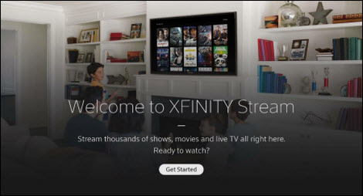
- The Activation screen with the activation code will appear on the Samsung Smart TV. Go to www.xfinity.com/authorize from a second screen (mobile, tablet or PC) web browser.
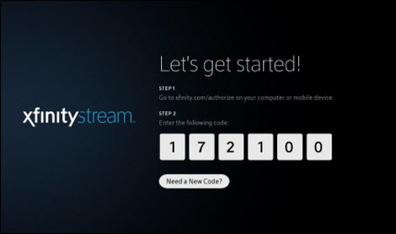
- From the external web browser, enter the six-digit device activation code that is provided in the Xfinity Stream beta app.
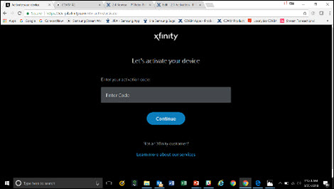
- Still from the web browser, enter your Xfinity username and password, then select Sign In.
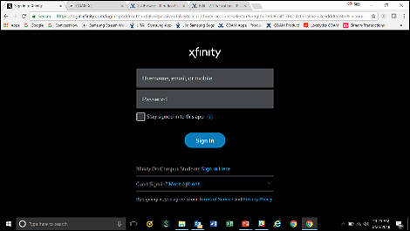
- The external web browser will display a Success! message, notifying you that your Samsung Smart TV has been activated and the activation screen on the Xfinity Stream Beta app will update shortly.
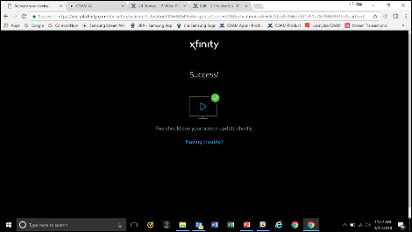
- After the successful activation of the Samsung Smart TV the Xfinity Stream Beta app Terms of Activation will be displayed. Scroll to read the terms and select Yes to accept the terms and continue. If you select No Thanks, you will be taken back to the first step of the activation process (Welcome screen).
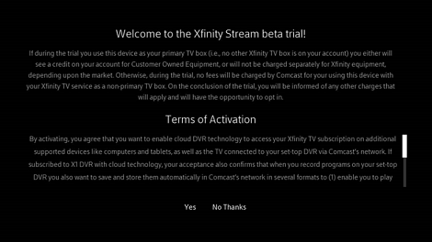
- Next, you will be asked to name your device. The device name is used to help with troubleshooting and device management settings that may be added in the future.
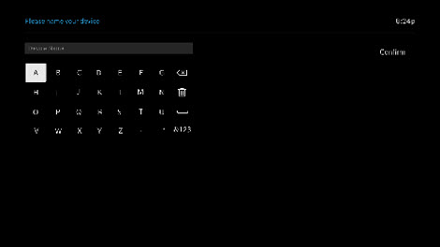
- The main menu should then appear, and you are ready to begin using the Xfinity Stream Beta app and enjoy your Xfinity TV or Xfinity Instant TV service!
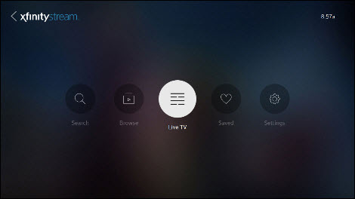

Navigate the Xfinity Stream Beta App on Samsung Smart TVs

Remote Control
You will need to use the Samsung OneRemote remote control to navigate the Xfinity Stream beta app. Basic navigational control is currently supported, including up/down, left/right, last and OK/select.
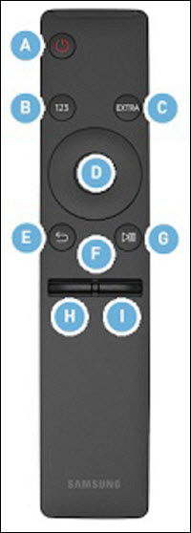
Button | Description
A. Power | Power On / Off.
B. 123 (Number pad) | When pressed, a number strip appears on the bottom of the screen. Select numbers and then select Done to enter a numeric value. Use to change the channel, enter a PIN, enter a ZIP Code, etc.
C. EXTRA | While watching content, press to display extra information from the content provider.
D. Directional / Select pad | Moves the focus and changes the values seen on the TV's menu. / Selects or runs a focused item. When pressed while you are watching content, detailed program information appears.
E. Return | Press to return to the previous menu. When pressed for one second or more, the running function is terminated. When pressed while you are watching a program, the previous channel appears.
F. Home | Press to return to the Home Screen.
G. Play / Pause | When pressed, the playback controls appear. Using these controls, you can control the media content that is playing.
H. Volume | Move the button up or down to adjust the volume. To mute the sound, press the button. When pressed for 1 second or more, the Accessibility Shortcuts menu appears.
I. Channel | Move the button up or down to change the channel. To see the Guide screen, press the button.

Main Menu
If the device has been activated, the Main Menu will be displayed after the app is launched. (See our activation instructions for more information.)
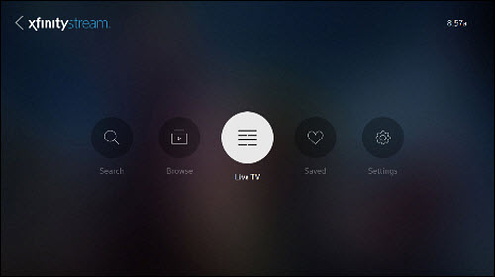
From the Main Menu, you will see the following buttons:
- Search
- Browse
- Live TV
- Saved
- Settings

Search
Pressing OK on the Search button on the main menu displays the Search page. You can search for a movie, TV show, or network (collection of channels). The search feature is supported with predictive search that provides search result as you enter the name. Recent search results are also displayed if applicable.
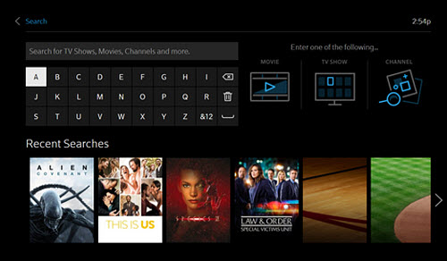
Browse
Pressing OK on the Browse button on the main menu loads the gallery of on-demand TV programs. The Browse section includes on-demand videos that are curated by TV, Movies, Networks, Sports, Kids, News and Latino. Special categories of curated on-demand videos will be displayed based on the editorial calendar (e.g. Olympics or World Cup).
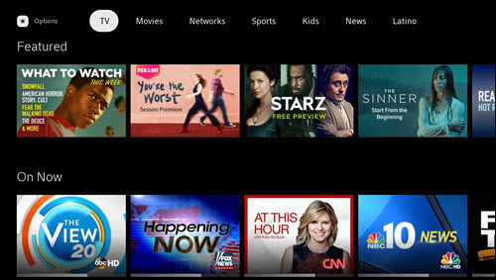
Live TV
Pressing OK on the Live TV button on the main menu loads the Live TV page and All Channels guide. All channels that are available in your Xfinity TV or Xfinity Instant TV subscription will be displayed. In addition to the Live TV grids, you can discover live programs in galleries based on curated categories, including Kids, Sports and Movies.
Currently available live programs can be watched by selecting a program from the guide then selecting the Watch button. A selection of the Last button while on a Live TV navigation tab menu loads the main menu.
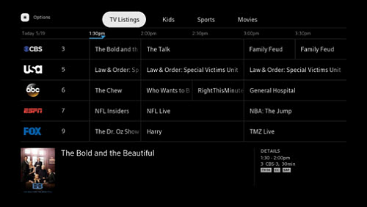
Live TV Options
Pressing OK on the Options button on the Live TV navigation menu loads the More Options modal over the Live TV guide. A Find Channels option will be available to search for specific networks or channels (including channel numbers) and either jump down the All Channels guide to that channel or immediately watch it.
Saved
Pressing OK on the Saved button on the main menu loads the For You navigation tab. The For You page includes live programs and on-demand TV shows and movies that are personalized for you. Other navigation tabs include Recordings and Schedule where you can watch and selectively manage (e.g. delete) your recordings from your TV box.
You can delete recordings by highlighting the TV episode, selecting Modify Movie Recording, followed by Delete Recording.
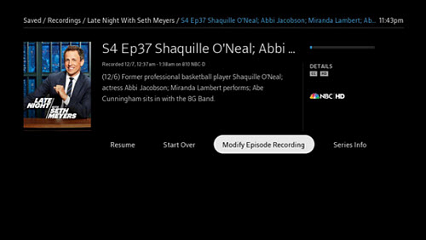
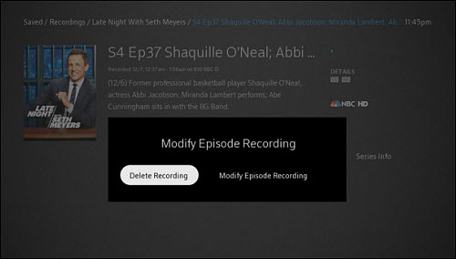

Note: You cannot delete recordings in bulk (for example, an entire series) on your Samsung TV. However, this can be done directly on your TV Box or by using the Xfinity Stream app. You may also recover recordings that were deleted in the past 24 hours by navigating to through the following menus - Saved > Recordings > Deleted Recordings - and selecting Undelete.
Settings
Selection of the Settings button on the main menu loads the Settings page. The supported feature settings include Language, Parental Controls and Accessibility. Other options in Settings include Help, Terms & Policies, About and Sign-Out.
Language settings allow you to set the default language for Secondary Language soundtracks (the SAP option will appear in Playback Controls when available). Language settings do not change the language for menus or TV listings.
Parental Controls allows you to restrict the type of content that is watched without a predetermined code. You can set your parental control personal identification number (PIN), modify it and cancel it. After a Parental Control PIN is created, the owner of the PIN can limit (i.e., Lock) the ability to watch content based on certain content ratings or Safe Browse to restrict the content that can be discovered in the content pages.
Accessibility settings allow you to toggle Closed Captioning On or Off, modify the look of the Closed Captioning text in your device settings, and toggle Video Description On or Off.
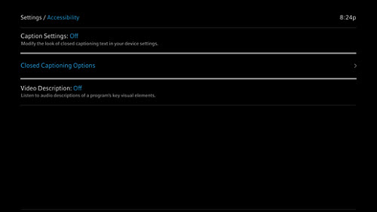
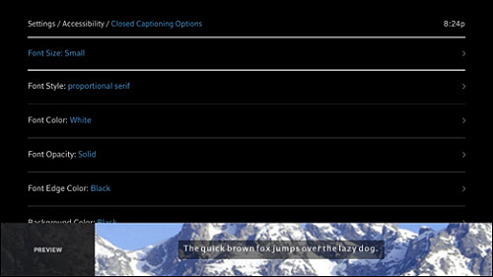

https://forums.xfinity.com/t5/Stream-TV-App/Xfinity-Stream-TV-app-on-Samsung-Smart-TVs/td-p/3138207

