

Shippensburg University
Student Accounts Office
Direct Deposit of Student Credit Balance Refunds
Name (Last name, first name, middle initial): Click or tap here to enter text.
Student ID: Click or tap here to enter text.
Daytime phone/cell #: Click or tap here to enter text.
I understand that once financial aid funds are distributed to pay tuition, fees, room and board, or I have paid more than the balance on my account, the Student Accounts Office will refund excess financial aid or payments to me through direct deposit. I also understand that I may designate any bank, savings and loans association or credit union in the United States that is a member of the Federal Reserve System and accepts electronic funds transfers.
I hereby authorized Shippensburg University to: (check one) ☐ START ☐ CHANGE ☐ STOP
direct deposit of my refund to:
Name of your Financial Institution: Click or tap here to enter text.
Transit Routing Number: Click or tap here to enter text.
Account Number: Click or tap here to enter text.
Type of account: (check one) ☐ Checking ☐ Savings
I have an established account at the financial institution indicated above and I authorize Shippensburg University to credit and debit entries to correct any credit entries made in error to my account indicated above. I have provided a copy of a voided check (see attached) solely for the purpose of verifying my account number and my financial institution’s routing number. (If you do not have checks or this is a savings account, you must contact your bank for the correct routing and account numbers. Deposit slips do not always contain the correct information and will not be accepted.)
I understand that my authorization will remain in effect until revoked by me in writing or until I terminate enrollment at Shippensburg University. If my enrollment resumes in the future, my direct deposit will automatically resume unless I otherwise notify the Student Accounts Office in writing. I understand that I must report, in writing, any change to my bank account that would affect my direct deposit. Additionally, I understand that it may take the Student Accounts Office up to two weeks to process any such change.
Please sign and date this form and return it to the address or email address listed below.
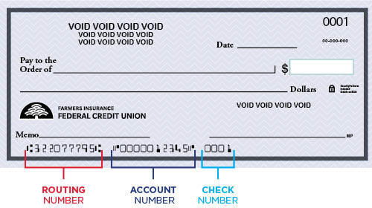
** Please submit a copy of your SU ID card with this form. **

Student Signature: Click or tap here to enter text. Date: Click or tap to enter a date.
Student Accounts Office, 1871 Old Main Drive, Old Main 112, Shippensburg, PA 17257 studentaccts@ship.edu

