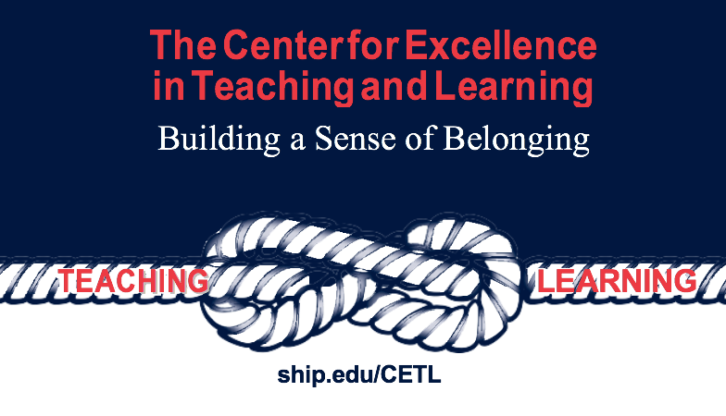
Syllabus Policies and Student Support Services

The Center for Excellence in Teaching and Learning has collected a number of SU policies and recommended practices that you might want to include in your syllabus this semester or as an appendix of course related expectations. Although this is not a comprehensive list of suggested language to support students’ understanding of how your course fits within our campus community and culture, suggestions below have been gathered from a number of offices and committees. This is a working document, so CETL welcomes your suggestions for syllabi language related to our policies and practices. Email CETL@ship.edu with your ideas or comments.

Raider Way
The Raider Way is a student-led initiative to better the campus community. It is designed to embrace diversity and emphasize inclusion. Eight key values structure the Raider Way, including: pride, honesty, belonging, acceptance, integrity, understanding, accountability, and respect. The Raider Way focuses on values that each Shippensburg University student is expected to 'live out' during their time at Ship and beyond. These eight values, developed by students as part of the Student Government Association and the Civility Committee coordinated by the Dean of Students and the Office of Multicultural Affairs, are core values that each Raider should transmit to better the campus community so that all feel welcomed and prideful of the wonderful place we all call home! For more information, see Raider Respect and
student life resources.

Productive Class Engagement
Classroom behavior or dispositions are demonstrated as part of our shared classroom culture. Your active participation is needed to establish and maintain a positive classroom climate for the success of all students in this course. These positive behaviors are reflective of the University’s core values of respect, responsibility, and integrity.

Below are some examples of productive and disruptive classroom behavior. To establish a collaborative and engaging environment for everyone in this course, please do your part to demonstrate the productive behaviors and avoid the disruptive behaviors. Disruptive behaviors can have negative consequences for students, including a referral to the Office of Student Conduct for disciplinary action. Information related to the Office of Student Conduct can be found at dean of students. Please review the information below and the behavior standards outlined in the student code of conduct.
Productive behavior in this class includes:
- Regular class attendance
- Arriving to class on time
- Completion of readings or other assignments on time
- Thoughtful participation and active involvement during class time
- Productive engagement with classmates about class material
- Respectfully interacting with professor and your classmates
- Engaging in conversation in an appropriate manner when contested issues are discussed
- Following all university and classroom expectations, including behaviors outlined in the student code of conduct
Disruptive behavior in this class includes:
- Sleeping
- Using a phone to text or chat
- Disrespectful, abusive, or intimidating comments
- Interrupting the professor or your classmates
- Blatant cheating, particularly during an examination or quiz
- Personal conversations between classmates during formal class discussions
- Non-compliance with university expectations, COVID-19 policy, expectations outlined in the syllabus, student code of conduct, and/or expectations verbally covered in class

COVID Risk Mitigation
Students must wear a face mask at all times in class and in the campus classroom buildings. More information about individual’s responsibility to protect the health and well-being of the entire campus community can be found on Shippensburg University’s website.

Title IX (mandatory syllabus statement)
Shippensburg University and its faculty are committed to assuring a safe and productive educational environment for all students. In order to comply with the requirements of Title IX of the Education Amendments of 1972 and the University’s commitment to offering supportive measures in accordance with the 2020 regulations issued under Title IX, the University requires faculty members to report incidents of sexual violence shared by students to the University's Title IX Coordinator at title9@ship.edu or by calling 717.477.1161.

The only exceptions to the faculty member's reporting obligation are when incidents of sexual violence are communicated by a student during: 1. a classroom discussion; 2. in a writing assignment for a class; 3. or as part of a University-approved research project. Faculty members are obligated to report sexual violence or any other abuse of a student who was, or is, a child (a person under 18 years of age) when the abuse allegedly occurred to the person designated in the
University protection of minors policy found at Equity, Inclusion and Compliance.

Information regarding the reporting of sexual violence and the resources that are available to victims of sexual violence is set forth at the following Equity, Inclusion and Compliance.

Academic Dishonesty and Plagiarism
All assignments are expected to be of high quality work and original for each student. Identification of sources is necessary when information or documents are from a published source. Failure to provide authentic work will result in failure of the assignment and/or course. Please refer to the University’s Academic Dishonesty Policy at Student Conduct.

Withdrawal from the Course
Students can drop the course within the drop/add period without ramifications to the students’ transcript, but after that time frame, a withdrawal from the course will result in a W grade on the transcript. To find out more information about withdrawing from the course, see the Registrar for more information.

Academic Policies
The undergraduate and graduate catalogs are the source for academic expectations. See catalogs for specific expectations. The Office of the Registrar maintains an up-to-date account of curricular and policy changes. Academic programs are managed at Department, College and Provost levels as part of shared governance structures coordinated by faculty, staff and administration.

Preferred Name
In an effort to continue building a more inclusive and affirming campus climate, the LGBTQ+ Concerns Committee collaborated with APSCUF's Social Justice Committee to develop a preferred name policy at Shippensburg University. This policy was unanimously approved by President's Cabinet in September, 2017. View specific details about Shippensburg University's Preferred Name Policy. Although a legal name and/or gender marker change is determined by the state in which a student, staff, or faculty resides in, the LGBTQ+ committee has worked to increase access for campus community members to utilize a preferred name in situations where a legal name is not required. Throughout the implementation process, the LGBTQ+ Concerns Committee will work to engage the campus community to increase awareness and offer support. If you have any questions, please feel free to contact Shippensburg University's Social Equity Office or the co-chairs of this committee.

Student Success
The Elnetta G. Jones University Center for Student Success and Exploratory Studies uniquely supplements and reinforces the university’s commitments to serve a more diverse student population and to cultivate a learning-centered environment where students persist to graduation. We enrich the teaching and learning mission of the university by delivering specialized, high-impact academic and student enrichment services that empower students to successfully attain their educational goals. See Student Success Center for more information.

Accessibility Resources
Shippensburg University is committed to providing equal opportunity for participation in all programs, services and activities. The University welcomes all students with disabilities into all of the University's educational programs and strives to make all learning experiences as accessible as possible. Any student who feels they may need an accommodation based on the impact of a disability should contact the Office of Accessibility Resources (OAR) to discuss specific needs. OAR is located in Mowery Hall 252 and can be reached by phone at (717) 477-1364 or via email at oar@ship.edu.

Campus Access and Use of Technology
Students have access to state of the art digital and computer technologies, including hardware and software for all campus related experiences. Students also have access to troubleshooting services located in the Ezra Lehman Library and via the SU Helpdesk at suhelpdesk@ship.edu. Information relating to SU Technology can be found at: technology and student help desk.

All users of the computing/information network facilities must act responsibly and maintain the integrity of these resources. The University reserves the right to limit, restrict, or extend computing/information network privileges and access to its resources. Information related to this policy can be found at: network usage.

